Lab 5 evidence:

Task 1:
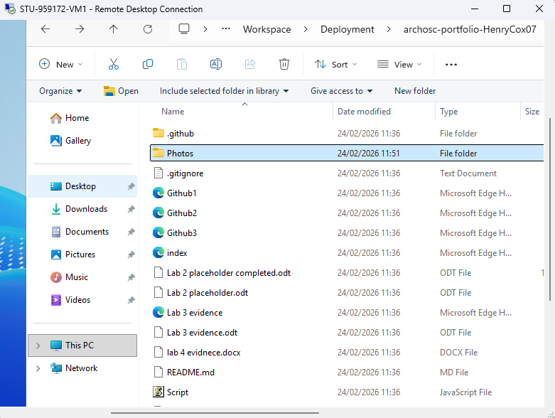
The first task of the lab required me to clone my repository on Github onto a virtual machine; to complete this task I had to log into the virtual machine download Git on the VM and then clone the contents into a repo.

Task 2:
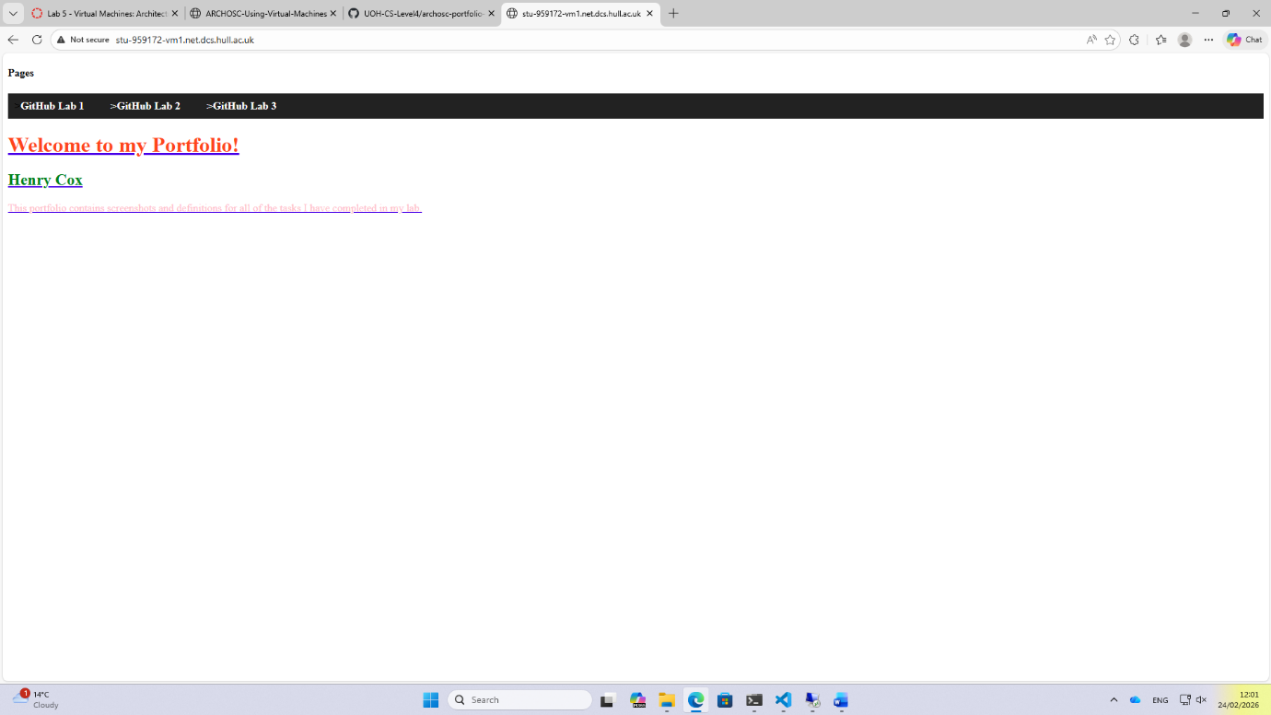
Next, I was tasked with hosting my website from the virtual machine so that I could view it on my local machine. To do this I had to move to the wwwroot folder in my virtual machine’s folder explorer and take the files for my website on the VM and paste them into the folder. After that I typed in a link that took me to my website being hosted from my VM.

Task 3 + 4:
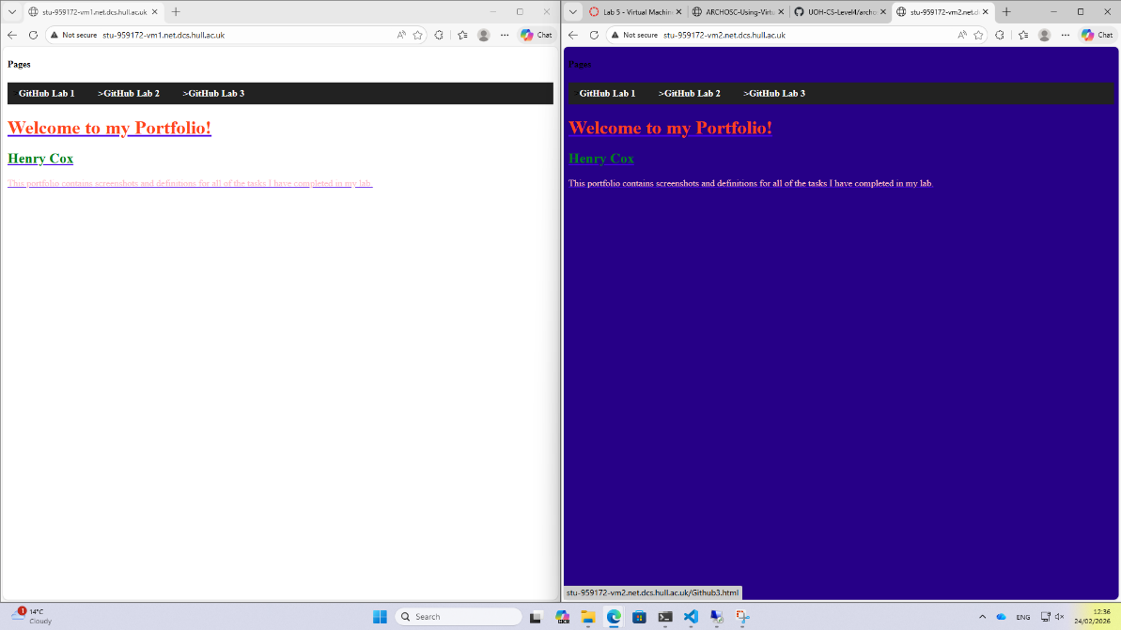

Finally, the final 2 tasks required me to create a new VM, put my repos contents on the new VM and host my website on the second VM as well as on the first VM which involved repeating the same steps from task 1 and 2. Once I hosted the website on the second virtual machine I had to show that I had made a change to the website on my second VM. To do this I had to install VS code on the second VM, paste the code for my website in to and make some changes to the website. Once I changed the background colour of my website on the second VM, I saved the changes, hosted the website of the second VM and then took this screenshot to show both VMs hosting each website.

